**Problem 2 : Image Map**

**AIM:**

Create a web page with the following using HTML5.

1. To embed an image map in a web page

(ii) To fix the hot spots

(iii) Show all the related information when the hot

spots are clicked.

**PROGRAM CODE:**



|  |  |
| --- | --- |
| Index.html | <!DOCTYPE html>  <html>  <body>  <p>Click on the computer parts to view the names of it:</p>  <img src="comp.jpg" width="450" height="450" alt="Planets" usemap="#desktop">  <map name="desktop">  <area shape="rect" coords="116,55,312,282" alt="Monitor" href="monitor.html">  <area shape="rect" coords="350,16,556,365" alt="CPU" href="cpu.html">  <area shape="circle" coords="326,396,25" alt="Mouse" href="mouse.html">  <area shape="rect" coords="05,405,280,330" alt="Keyboard" href="keyboard.html">  </map>  </body>  </html> |
| Monitor.html | <html>  <head>  <title>Monitor</title>  </head>  <body bgcolor="lightblue">  <h1> Monitor</h1></br>  <p>  <img src="monitor.jpg" width=300 height=300></br>  A computer monitor is an output device that displays information in pictorial form. A monitor usually comprises the display device, circuitry, casing, and power supply. The display device in modern monitors is typically a thin film transistor liquid crystal display (TFT-LCD) with LED backlighting having replaced cold-cathode fluorescent lamp (CCFL) backlighting. Older monitors used a cathode ray tube (CRT). Monitors are connected to the computer via VGA, Digital Visual Interface (DVI), HDMI, DisplayPort, Thunderbolt, low-voltage differential signaling (LVDS) or other proprietary connectors and signals.  </p>  </body>  </html> |
| Keyboard.htm | <html>  <head>  <title>Keyboard</title>  </head>  <body bgcolor="lightblue">  <h1> Keyboard</h1></br>  <p>  <img src="keyboard.jpg" width=300 height=300></br>  A computer keyboard is a typewriter-style device which uses an arrangement of buttons or keys to act as mechanical levers or electronic switches. Following the decline of punch cards and paper tape, interaction via teleprinter-style keyboards became the main input method for computers.  </p>  </body>  </html> |  |
| Mouse.html | <html>  <head>  <title>Mouse</title>  </head>  <body bgcolor="lightblue">  <h1> Mouse</h1></br>  <p>  <img src="mouse.jpg" width=300 height=300></br>  A computer mouse is a hand-held pointing device that detects two-dimensional motion relative to a surface.  </p>  </body>  </html> |  |
| Cpu.html | <html>  <head>  <title>Central processing unit  </title>  </head>  <body bgcolor="lightblue">  <h1> Central processing unit  </h1></br>  <p>  <img src="cpu.jpg" width=300 height=300></br>  A central processing unit (CPU), also called a central processor or main processor, is the electronic circuitry within a computer that carries out the instructions of a computer program.  </p>  </body>  </html> |  |

**RESULT**

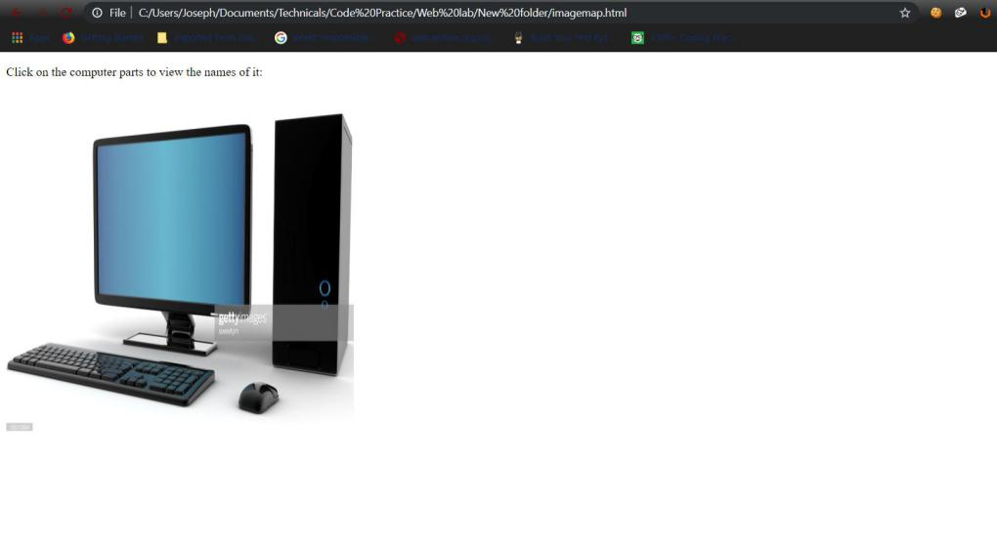

Figure 1: index.html

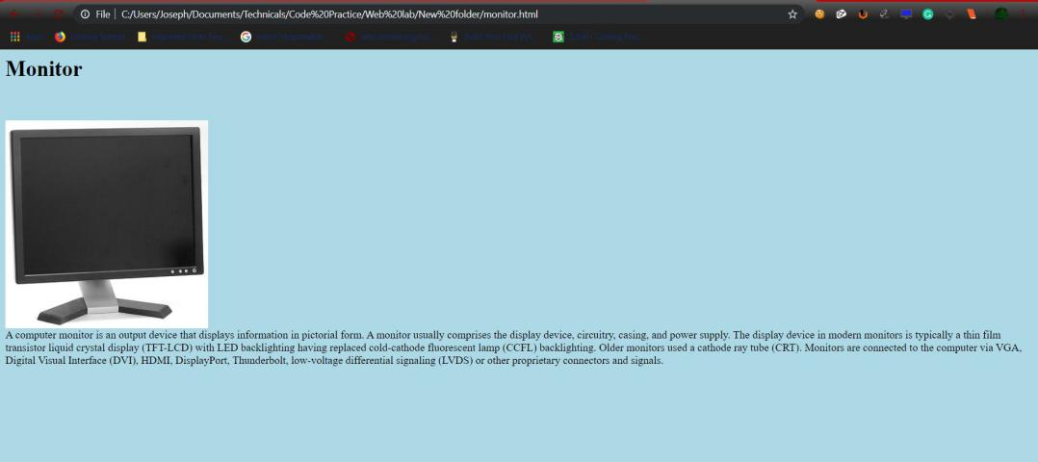

Figure 2: monitor.html

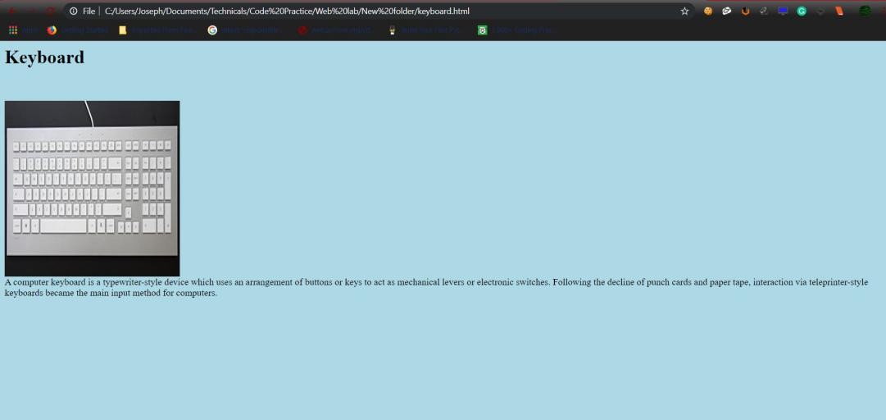

Figure 3: keyboard.html

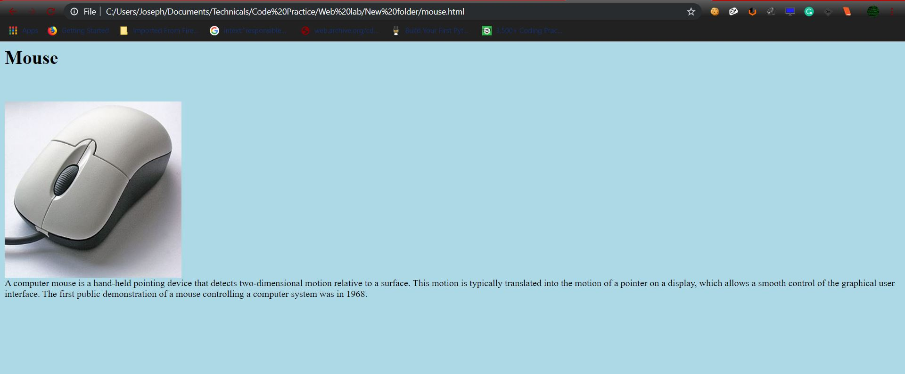

Figure 4: mouse.html

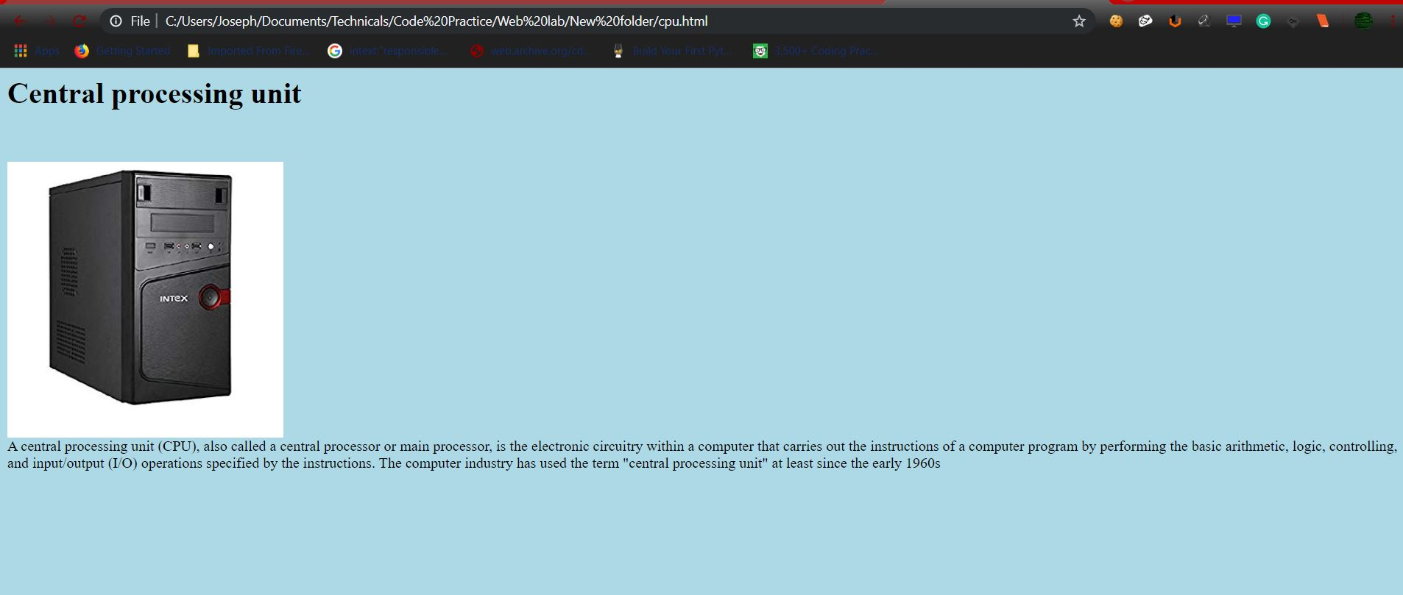

Figure 5: cpu.html